- Bluebook Page51 August 2019 Variant Four examination:

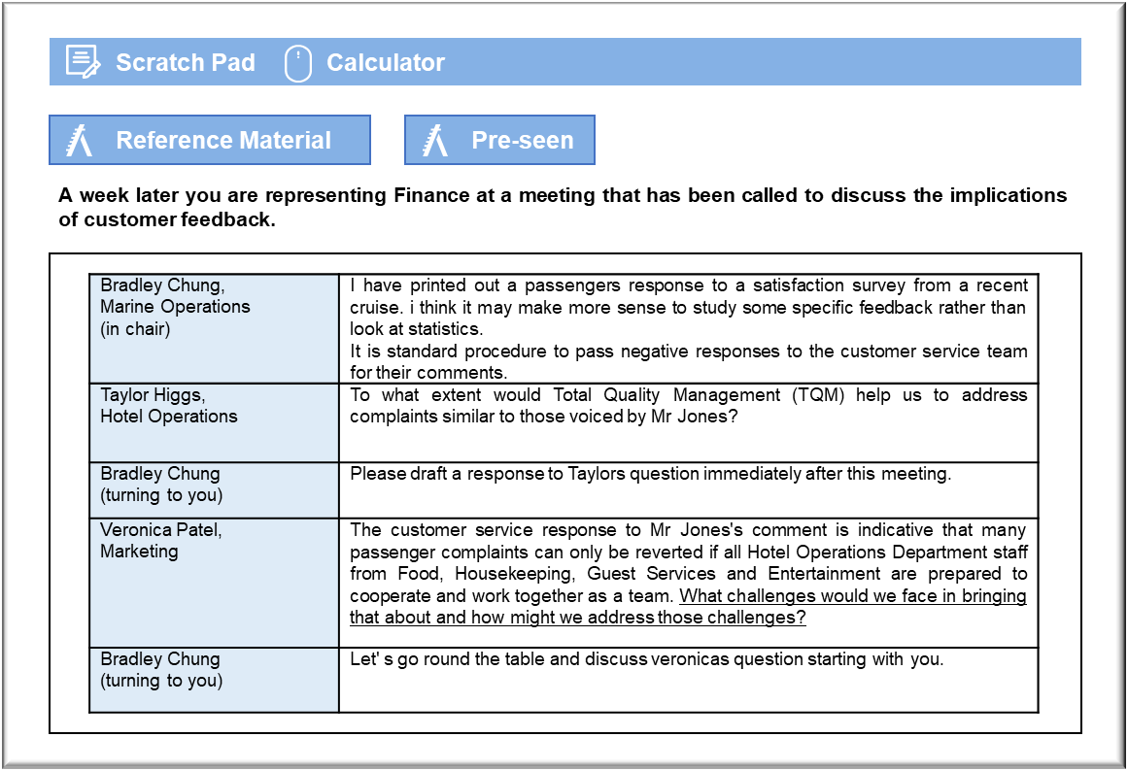

MANAGEMENT CASE STUDY AUGUST 2019 EXAM ANSWERS

Variant4 Task2
These answers have been provided by CIMA for information purposes only. The answers created are indicative of a response that could be given by a good candidate. They are not to be considered exhaustive, and other appropriate relevant responses would receive credit.

CIMA will not accept challenges to these answers on the basis of academic judgement.

Requirement 1: Total quality management
The purpose of TQM is to prevent quality errors from occurring, so that complaints are not made in the first place and external failure costs are avoided, at least as far as possible. In this case, there have clearly been two quality errors in respect of the cleanliness of the corridors adjacent to Mr. Jones’ cabin, which will have affected not only Mr. Jones, but the other passengers whose cabins were nearby. Firstly, the designated cleaner who was responsible for that area was negligent in failing to keep it clean and, secondly, there was no follow-up once the problem was reported to check that the work had been done since. It is generally cheaper to prevent costs than to rectify them once they occur, and that is clearly the case here because a cleaner had been paid to clean the corridor, suggesting that the marginal cost of keeping the corridor clean is effectively zero.
TQM stresses continuous improvement, which means that zero errors should be a goal, with
constant effort to reduce errors. In this case, the Guest Services Adviser should have made a
follow-up inspection to ensure that the dirty corridor had been cleaned properly. A prompt
inspection would have made it possible to avoid further irritating the passenger. A TQM
programme would require the cleaners to identify problems that may cause quality errors. It is, for example, possible that the corridor was cleaned thoroughly on a regular basis, but quickly became dirty. Under TQM, the cleaners would identify problems and would recommend changes that might help to resolve them, such as replacing the floor covering with something that did not trap dirt. It might even be worth implementing quality circles so that groups of crew members can address problems and identify responses more effectively.
TQM will not prevent every quality issue from arising and, in some cases, it may be impossible to attempt to do so because a solution would be unduly inconvenient or expensive, thereby creating prevention and appraisal costs. Mr. Jones’ complaint that his allocated cabin was noisy because of a nearby elevator could only really have been prevented by switching him to a quieter part of the ship whenever a space became available and putting another passenger in his original cabin. Continuous improvement would be possible to a limited extent if Cruisecalm was willing to spend more on soundproofing any machinery on board ship that might disturb passengers. Even then, there would still be scope for disturbance. In this instance, “quality” would have to be determined in relation to the fact that a cruise holiday will necessarily expose passengers to some noise from shipboard systems and that passengers will have to accept such disruption as part of their choice of holiday.

Requirement 2: Cooperation
The most immediate challenge is that the individual members of Hotel Department staff may
have their own agendas with regard to their interaction with passengers. That was highlighted by the fact that Mr. Jones singled out for praise the cleaner who had failed to keep the corridor outside of his cabin. It may be that the cleaner saw some advantage in focusing on cleaning passenger cabins, because of the possibility of such positive feedback and of gratuities, such as that provided by Mr. Jones.
The feedback from passengers tends to suggest that some roles are more likely to be
appreciated than others. That might deter staff in roles that are traditionally valued by passengers from working closely with others, because those staff will be aligning themselves with colleagues whose scores will dilute their own. They may resent any suggestion that they should accept a collective responsibility for overall passenger satisfaction when they already appear to be succeeding in their own areas.
One response to the challenge of individual agendas would be stop passing on detailed
passenger feedback to individual members of staff, so that they felt less pressure to prioritise
positive comments . Staff appraisals could focus on the impressions of supervisors and
managers, who may be more objective about the overall performance of their staff. It may also August 2019 4 Management Case Study Exam be possible to reduce the emphasis on personal gratuities by having passengers pay them to a central location and sharing them in accordance with a formula.
A greater sense of collective responsibility might be created by having a broader approach to feedback that forces staff to work together. For example, the feedback regarding the restaurants suggests that passengers like the waiting staff but are unhappy with the food, which suggests that there is a wasted opportunity. If the feedback took a broader view of the overall dining experience, then the waiting staff could be given more of an incentive to ask about the food and to give the kitchen staff a better indication of how to improve.

